Alpha Gamma Sigma of Pasadena City College
Alpha Chapter Tuesday, February 17, 2015
Executive Board C415, PCC |12- 1:00 PM
Planning Meeting

Public Participation: Members of the Public are invited to speak concerning any item of business on this agenda at the end of the Alpha Gamma Sigma Executive Board’s discussion of the item. For matters not listed on this agenda that are under the Board’s jurisdiction, members of the public are invited to address the Board during Public Comment. Please, limit your comments to no more than 2 minutes.

- Call To Order: 12:15 pm
- Roll Call
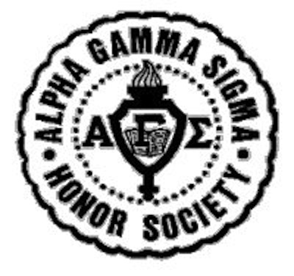
President Marissa Davis
Internal Vice President
Rachel Pagador
External Vice President Leonardo Sandoval
Corresponding Secretary Darla Zacarias
Recording Secretary
Brian Park
Treasurer Jonathan Suriawijaya
Fundraiser Coordinator
Priscilla Wong

Marketing Director Janam Dave
Publicity Director Keilah Kelso
Activities Coordinator Anna Chon
Technology Coordinator Kevin Permana
Assistant Technology Coordinator
Vicki Vong
ICC Representative Jenny Chuang

- Approval of Agenda and Minutes — First Approved: Anna Chon; Second Approved: Jonathan Suriawijaya
- Action & Discussion Items
Discussion Items:
- Selling our AGS wear to other AGS Chapters
We will discuss how we plan to reach out to other chapters.
- Post up on Alpha blog
- Show other chapters which AGS wear we have and then have them preorder.
  - Send payment to us and we will mail them to other chapters.
- AGS BOARD—Bring one size of each AGS wear that you have.
- Jonathan will bring AGS wear
- Paypal possibility
- Banquet
We will be discussing the date and budget for the 2014-2015 Spring Banquet.
- Combining Fall and Spring Banquet
- Banquet Spring 11
  - Mt Sac Zeta
  - Ctirus Iota
  - West LA
  - Antelope Valley Alpha Iota
- Rachel and Marissa will start contacting them
- First week of March
- Black and White— Noir
- Scholarships
  - Turn in applications—March 16
- Stonefire food
- Anna make a spreadsheet of estimate purchases

- American Red Cross, Blood Drive & Be The Match, Bone Marrow Drive
We will be discussing how we are moving forward with American Red Cross. We will also discuss any updates that the directors have.
- Wednesday meeting—11-12
- Reapply
- Apps due Thursday, February 20.
- Fundraising Opportunities
We will be discussing the different opportunities we have this semester. Also, we will create a list of vendors we are interested in contacting.
- Au79 FUNDRAISER MARCH
  - Fundraising slips will be made by Priscilla
- DAVE & BUSTER’S APRIL FUNDRAISER
- PIZZA FUNDRAISING PLACE
- TASTE OF PASADENA FUNDRAISER
  - Contact different restaurants for fundraising
- Executive Bonding & Retreat
We will be discussing what activity we will do on Feb 28.
We will be discussing the date and location of our retreat.
- Will discuss ideas on facebook.
- Newsletter & Upcoming Events
  - AU FUNDRAISER! – Entire month of March!
  - Monthly Board Bonding- Feb 28
- Board Reports & Announcements
- President’s Report
To our wonderful Executive members,
We are moving into this semester very quickly. I ask that you all keep constant and consistent communication with me and our fellow Executive members. This includes being present and aware of the different aspects of our society- on our FB Executive page, FB Alpha page, our AGS website, our Weebly page, at our planning and general meetings.
Furthermore, I ask that you all gain access to our calendar. Please make note of the events coming up, and prepare yourself to take on the responsibilities of your position. Although it is my duty to administer the cabinet’s duties, I expect each Executive Member to be fully aware of the upcoming events and have thought out ideas regarding how your position will make a positive impact for each.
I look forward to an amazing semester with you ALL! Xoxo
- Advisor’s Report
- Future Agenda Items (subject to change)
- Supporting other clubs on campus
- Storage of AGS wear, equipment, and supplies
- Expanding our Committees
- Audience Participation & Announcements
- Future Meeting Date and Time
General Meeting Thursday — February 19, 2015 ⎢12:00PM ⎢UU Forum
Planning Meeting Tuesday — February 24, 2015 ⎢12:00PM ⎢C 415
- Meeting Adjournment 12:52 pm

